**A CAPSTONE REPORT**

**Academic Activities Prediction And Guiding System For University Students**

*by*

|  |  |
| --- | --- |
| **Md. Amanullah Aman** | **ID: 16173103074** |
| **Kreshan Sarker** | **ID: 16173103060** |
| **Sajib Chandra Debnath** | **ID: 16172103093** |
| **Rakibul Islam Rinku** | **ID: 17182103063** |
| **Sumaya Akter Nipa** | **ID: 16172103075** |

***Project Report Submitted in Partial Fulfillment of***

***The Requirements for The Degree*  
*of*  
Bachelor of Science in Computer Science and Engineering (CSE)**



**DEPARTMENT OF COMPUTER SCIENCE AND ENGINEERING  
BANGLADESH UNIVERSITY OF BUSINESS AND TECHNOLOGY**

**June, 2022**

# DECLARATION

We do hereby declare that the project entitled “**Academic Activities Prediction And Guiding System For University Students**” submitted for the degree of Bachelor of Science Engineering in Computer Science and Engineering in the faculty of Computer Science and Engineering of Bangladesh University of Business and Technology (BUBT), is our original work and that it contains no material which has been accepted for the award to the candidates of any other degree or diploma, except where due reference is made in the next of the project to the best of our knowledge, it contains no materials previously published or written by any other person except where due reference is made in this project.

**Sajib Chandra Debnath ID: 16172103093**

**Intake: 35th**

**Section: 02**

**Kreshan Sarker  
ID: 16173103060**

**Intake: 36th**

**Section: 02**

**Md. Amanullah Aman  
ID: 16173103074**

**Intake: 36th**

**Section: 02**

**Rakibul Islam Rinku ID: 17182103063**

**Intake: 38th**

**Section: 02**

**Sumaya Akter Nipa**

**ID: 16172103075**

**Intake: 35th**

**Section: 02**

# APPROVAL

This project “**Academic Activities Prediction And Guiding System For University Students**” report submitted by Md. Amanullah Aman, Kreshan Sarker, Sajib Chandra Debnath, Rakibul Islam Rinku Rakibul Islam Rinku and Sumaya Akter Nipa students of Department of Computer Science and Engineering, Bangladesh University of Business and Technology(BUBT), under the supervision of **Md. Saifur Rahman**, Assistant Professor & Chairman, Department of Computer Science and Engineering has been accepted as satisfactory for the partial requirements for the degree of Bachelor of Science Engineering in Computer Science and Engineering.

**Md. Saifur Rahman**  
Assistant Professor & Chairman   
Department of CSE

Bangladesh University of Business and Technology

# ACKNOWLEDGEMENTS

We would like to express our deep and sincere gratitude to our project supervisor, Md. Saifur Rahman, for giving us the opportunity to conduct project and providing invaluable guidance throughout this work. His dynamism, vision, sincerity and motivation have deeply inspired us. He has taught us the methodology to carry out the work and to present the works as clearly as possible. It was a great privilege and honor to work and study under his guidance.

We are greatly indebted to our honorable teachers of the Department of Computer Science and Engineering at the Bangladesh University of Business and Technology who taught us during the course of our study. Without any doubt, their teaching and guidance have completely transformed us to the persons that we are today.

We are extremely thankful to our parents for their unconditional love, endless prayers and caring, and immense sacrifices for educating and preparing us for our future. We would like to say thanks to our friends for their kind support and care.

Finally, we would like to thank all the people who have supported us to complete the project work directly or indirectly.

*Md. Amanullah Aman, Kreshan Sarker, Sajib Chandra Debnath,*

*Rakibul Islam Rinku and Sumaya Akter Nipa.*  
Bangladesh University of Business and Technology.

# DEDICATION

Dedicated to  
 – *Our Parents*

# ABSTRACT

The main assets of universities are students. The performance of students plays a vital role in producing excellent graduate students who will be the future viable leader and manpower in charge of a country's financial and societal progress. The purpose of this research is to develop a “Academic Activities Prediction and Guiding System for University Students” that can help the students to predict their results and to identify their lacking so that they can put concentration to overcome these lacking and get better outcomes in the upcoming semesters. The prediction system can help not only the current students but also the upcoming students to find out exactly what they should do so that students can avoid poor achievement that will help to increase their academic results and other skills. To predict performance, we collected data from the university student’s database containing information, extracurricular activities, programming skills, class test mark, assignment mark, attendance, and previous semester Grade Point Average (GPA), where the main aim is to relate to student performances and Cumulative GPA (CGPA). We use filtering method to predict result. These rules used to develop a web-based system that can predict the grade points of students from their previous records. Moreover, the system notifies students’ lack and gives suggestions to improve their results.

**LIST OF ABBREVIATIONS**

Hypertext Preprocessor (PHP)

Cascading Style Sheets (CSS)

JavaScript (JS)

Hypertext Markup Language (HTML)

**LIST OF FIGURES**

Figure 1.1 The figure illustrates the flow of the project work ……………………...04

Figure 3.1 Prototype Model Process …………………………………………….….16

Figure 3.2 Prototype Model Phases……………………….………………………...17

Figure 3.3 Context Level Diagram for student performance and guiding system.….17

Figure 4.1 Database Schema……….………………………………….…………….20

Figure 4.2 Admin Login…………………………...………………………………....21

Figure 4.3 Admin Dashboard…………………………………………….………….22

Figure 4.4 Add University basic info………………………….….…………………22

Figure 4.5 Add Department…….…………………………….…….............................23

Figure 4.6 Add Course Details…….…………….……..............................................23

Figure 4.7 Add Current Semester…….…………………………………...….……...24

Figure 4.8 Add Intake…….……………………………………………….….……...24

Figure 4.9 Add Section…….………………………………………...……….……...25

Figure 4.10 Add New Student…………………………………...…………….……...25

Figure 4.11 Add New Teacher…….………………………………….……….……...26

Figure 4.12 Offer Courses…….……………………………………………….……...26

Figure 4.13 Assign Courses…….……………………………………….…….……...27

Figure 4.14 Student Login…….……………………………………………….……...27

Figure 4.15 Student Dashboard………………………………….…………….……...28

Figure 4.16 Academic Information…….……………………………..……….……...28

Figure 4.17 Course Registration…….………………………………...……….……...29

Figure 4.18 Teacher Login…….………………………………………...…….……...29

Figure 4.19 Teacher Dashboard…….……………………………...………….……...30

Figure 4.20 Assigned courses…….……………………………………...…….……...30

Figure 4.21 Input Marks…….……………………………...………………….……...31

Figure 4.22 Academic Information…….…………………………..………….……...32

Figure 4.23 Previous Semester Courses performances…….………………….……...32

Figure 4.24 Present Semester Courses…….…………….……………………….…...33

Figure 4.25 Performances Prediction based on previous course data……...….……...33

Figure 4.26 Performances Prediction based on previous semester…...……….……...34

Figure 4.27 Performances Progress…….……………………………………...……...34

Figure 4.28 Guideline for Better Performances……………………………….……...35

Figure 4.29 Progress Bar Description…….…………………………………...……...35

Figure 7.1 Gantt chart of the work execution process…….……...……….……..39-40

# Table of Contents

|  |  |
| --- | --- |
| **Declaration………………………………………………………………………...** | **ii** |
| **Approval….……………………………………………………………………….** | **iii** |
| **Acknowledgements……………………………………………………………….** | **iv** |
| **Dedication…………………………………………………………………………** | **v** |
| **Abstract……………………………………………………………………...........** | **vi** |
| **List of Abbreviation.………………………………………………………….….** | **vii** |
| **List of Figures…………………………………………………………………….** | **viii-ix** |
|  |  |

|  |  |  |  |
| --- | --- | --- | --- |
| **Chapter 1:Introduction....……………………………………………..……..........** | | | **1-5** |
| 1.1 | Introduction....…….……………………………………….……..………….. | | 1 |
| 1.2 | Problem Statement…………………………………………..………………. | | 1 |
| 1.3 | Problem Background ………………………………………………………... | | 2 |
| 1.4 | Project Objectives ……………………………………………..…………….. | | 2 |
| 1.5 | Motivation …………………………………………………………...…….... | | 2 |
| 1.6 | Significance of the Project ………………………………………...………… | | 3 |
| 1.7 | Flow of Project …………………………………………………..…………. | | 3 |
| 1.8 | Report Contribution………………………………………………..………… | | 4 |
| 1.9 | Report Organization…………………………………………………………. | | 5 |
| 1.10 | Summary……………………………………………………….…………….. | | 5 |
|  |  | |  |
| **Chapter 2: Background……………………………………………………………** | | | **6-9** |
| 2.1 | Introduction.………………………………………………………..………... | | 6 |
| 2.2 | Literature Review.………………………………………………..………….. | | 6 |
| 2.3 | Problem Analysis.……………………………………………………... | | 9 |
| 2.4 | Summary………………………………………………………………… | | 9 |
|  |  | |  |
| **Chapter 3: Proposed System……………………………………………………..** | | | **10-18** |
| 3.1 | Introduction……………………………………………………………….…. | | 10 |
| 3.2 | Feasibility Analysis………………………………………………………….. | | 10 |
|  | 3.2.1 | Technical Feasibility……………………………………..…………. | 10 |
|  | 3.2.2 | Economic Feasibility………………………………………………… | 11 |
|  | 3.2.3 | Operational Feasibility………………………………...........……….. | 11 |
| 3.3 | Requirement analysis……………………………………………….………. | | 11 |
|  | 3.3.1 | Xampp……………………………………………………….……….. | 12 |
|  | 3.3.2 | MySql Database………………………………………….………….. | 12 |
|  | 3.3.3 | PHP…………………………………………………………………. | 13 |
|  | 3.3.4 | HTML………………………………………………………………. | 13 |
|  | 3.3.5 | CSS………………………………………………………………….. | 13 |
|  | 3.3.6 | Bootstrap……………………………………………………………. | 14 |
|  | 3.3.7 | JavaScript (JS)……………………………………………………… | 14 |
| 3.4 | Modules…………………………………………...………………………… | | 14 |
|  | 3.4.1 | Admin Module………………………………………………………. | 14 |
|  | 3.4.2 | Teacher Module………………………………………………..……. | 15 |
|  | 3.4.3 | Student Module……………………………………………..……….. | 15 |
| 3.5 | Methodology………………………………………………………….……… | | 15 |
|  | 3.5.1 | Prototype Model…………………………………………….……….. | 16 |
|  | 3.5.2 | DFD in our System………………………………………….……… | 17 |
| 3.6 | Design, Implementation and Simulation……………………………...…….. | | 18 |
| 3.7 | Summary………………………………………………………………...…… | | 18 |
|  |  | |  |
| **Chapter 4: Implementation, Testing and Result Analysis……………………..** | | | **19-35** |
| 4.1 | Introduction.……………………………………………………………..…... | | 19 |
| 4.2 | Database Schema ………………………………………….........…………... | | 129 |
| 4.3 | Implementation Phase ………………….....………………………………… | | 21 |
|  | 4.3.1 | Admin Module Functionalities…………………………………...….. | 21 |
|  | 4.3.2 | Student Module Functionalities………………………………..…….. | 27 |
|  | 4.3.3 | Teacher Module Functionalities……………………………….…….. | 29 |
| 4.4 | Data Filtering Technique…………………………….........……………..…... | | 31 |
| 4.5 | Testing and Result Analysis………………………….........………...………. | | 32 |
| 4.6 | Summary…………………………………………...…………….......……… | | 35 |
|  |  | |  |
| **Chapter 5: Standards, Ethics and Challenges…………………………….……..** | | | **36** |
| 5.1 | Impacts on Society ………………………………………..…………...……. | | 36 |
| 5.2 | Challenges …………………………………..……………..………………... | | 36 |
| 5.3 | Summary…………………………………………...…………….…..……… | | 36 |
|  |  | |  |
| **Chapter 6: Constraints and Alternatives……………………………………...….** | | | **37-38** |
| 6.1 | Project Constraints ………………………………….…………...………….. | | 37 |
| 6.2 | Design Constraints ……………………………………………..…………… | | 37 |
| 6.3 | Component Constraints …………………………………………………….. | | 37 |
| 6.4 | Budget Constraints …..………….……..…………….…….………..……… | | 37 |
| 6.5 | Summary…………………………………………...…….…………..……… | | 38 |
|  |  | |  |
| **Chapter 7: Schedules, Tasks, and Milestones……………………………………** | | | **39-40** |
| 7.1 | Timeline………………................……………..……………..………..…….. | | 39 |
| 7.2 | Gantt Chart…………………………............……………..…………….…… | | 39 |
|  |  | |  |
| **Chapter 8: Conclusion and Future Work ………………………..………….…..** | | | **41** |
| 8.1 | Conclusion………………………….........……………..……………..……... | | 41 |
| 8.2 | Future work……………………………………...……………..…….……… | | 41 |
|  |  | |  |
| **References…………………………………………………………………………..** | | | **42-43** |

# Chapter 1 INTRODUCTION

* 1. **Introduction**

Academic Activities Prediction And Guiding System For University Students is a web based application developed for universities to analyze the result and keep track of students. We are able to see the individual candidate’s results separately. Student result prediction and guiding system has been designed to carry out the result analysis process in an educational institution. This application used for the analyzing the student results according to the user requirements and generate the performance report of student, subject. It also allows the student to see their individual performance in semester. This will help the universities management to take the appropriate actions to improve the quality of education and helps in improving the performance of students. The results of respective departments can be efficiently computed without much of manual involvement. Given the continuous rise in student population, tertiary institutions calculate examination result of students with the help of computer programs. Many algorithms and programs to compute examination result of students have been developed. However, the use of programs that extends capabilities beyond examination result computation is not widespread. The system provides a comprehensive solution to the demand of examination result computation as well as predict student academic performance.

* 1. **Problem Statement**

In Bangladesh, advancement in technology is also remarkable. Science and technology education are getting a new dimension. A large number of students are interested to admit in different science and engineering universities. It is a very good sign, but we need to ensure the quality of the graduates that we cannot ensure in many cases. So, we need to find out the factors with which student's academic performance depends and addressing them in a paradigm so that academic performance can increase.

* 1. **Problem Background**

Although some academic performance prediction approaches proposed for various countries, in Bangladesh, enough works have not done yet in this area. We find only works in this area. The authors of [1] have introduced an approach to predict the student’s results in the form of CGPA using neural networks technique where they collected data from a university of Bangladesh. They showed that student’s yearly performance greatly depends on both academic and non-academic activities. However, they work on a comparatively small dataset and do not provide suggestions for improvement. So, this paper aims to the development of an effective university student result analysis and prediction system that can predict semester results, will show their lacking, and give valuable suggestions to overcome the lacking and hence to improve their performance.

* 1. **Project Objectives**

A web based system will be developed to predict the current academic situation of a student to achieve the goal on this sector analyzing successful student data.

* 1. **Motivation**

Nowadays the number of engineering student in the universities has been increased in Bangladesh. We see that some student can success but the others can’t achieve their goal. Primarily We can find out the reason that why they can’t reach the goal. Firstly, they don’t care about their result at first some semesters. They can’t find out which courses are more important and how to deal with these courses. Most of them are weak in fundamental courses that’s why they suffer in the last some semesters. To solve these problems we can analysis the successful student who have completed all courses with good result. Then using the filtered data we can design and develop a system which can be used an guiding system that will predict the current academic activities and will show the instruction how to improve and deal with the current academic activities of a student. Following the roadmap those students can achieve their goal.

* 1. **Significance of the Project**

We observe that most of the predicting system only predict the activities but it can’t give a road map to the student. We use filtering method to develop the system. These rules used to develop a web-based system that can predict the grade points of students from their previous records. Moreover, the system notifies students’ lack and gives suggestions to improve their results.

* 1. **Flow of Project**

The project work is developing into several steps. First, we have analyzed the Project topics and then studied the basic theory of filtering data. Then we have investigated the application of prediction system. We investigated the lack of present architectures and motivated them to build a new architecture based on filtering approaches. Figure 1.1 illustrates the overall steps to the project procedure in the following diagram.

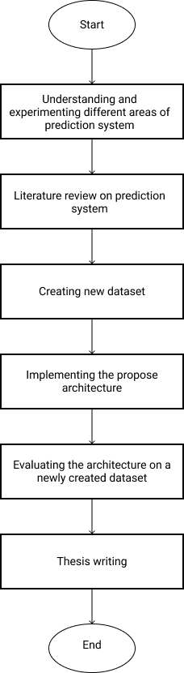

**Report Writing**

**Figure 1.1:** The figure illustrates the flow of the project work

* 1. **Report Contribution**

The overall contribution of the project work includes:

* The attributes considered for this report consist of a mixture of students’ general and academic data. Moreover, the work aims to identify the important attributes for predicting the results.
* In this work, we designed a web-based environment where a teacher can input the required (e.g programming skill, CT marks, mid marks, final marks etc) data, and the system shows students the predicted results based on entry data.
* The developed system will provide the reasons behind the results fall, and also provide valuable suggestions to improve their performance.
  1. **Report Organization**

The project work is Organized as follows:

Chapter 2 highlights the background and literature review.

Chapter 3 contains proposed system and a detailed walk-through of the overall procedures.

Chapter 4 includes the Implementation, Testing, and Result Analysis.

Chapter 5 explains Standards, Impacts, Ethics, and Challenges.

Chapter 6 contains Constraints and Alternatives of the project.

Chapter 7 elaborate the time schedules that we managed while the project work was conducted.

Finally, Chapter 8 contains the overall conclusion of our project work

* 1. **Summary**

This chapter includes a broad overview of the problem that we aimed explicitly at our project work’s objectives, the background, and the project work’s motivation. This chapter also illustrates the overall steps on which we carried out our project work.

# Chapter 2 BACKGROUND

**2.1 Introduction**

Much research has been done in the area of educational data analysis where a predictive logic is built to forecast the performance of students to identify the at risk students. This problem can be considered a hard problem because the performance depends on many characteristics related to the students. In this paper, we have presented a fragment of some of the work enforced by the researchers.

**2.2 Literature Review**

For educational measurement processes test and result analysis of annual examination based on the university exam of student. This system is mainly based on the database technology and the Choice Base Credit Based system. This system is developed for analysis of the MSc (Computer science) result [2]. This paper analyses and predicts students performance using data mining techniques for two data sets of 1000 students each one for Mathematics, and the other for System Analysis, and Design. This study can help the education community to understand learning behaviour of students as far as courses of varying difficulty are concerned.J48 supplemented by AdaBoost performs excellent for System Analysis, and Design but perform worst for mathematics and M5P generates best results for early prediction of students’ marks in the major test [3].

Using decision tree algorithm C4.5 to establish a classification rule and an analysis forecasting model for students marks. The effectiveness and correctness of analysis and forecasting model and classification for students marks based on decision tree algorithm C4.5 has been examined by an example [4].

A multiclass classification refers to the classification of the instance into more than two classes. Multiclass classification and prediction is suitable for hand written digit recognition, hand written character recognition, speech recognition and body parts recognition etc. This paper compares five classification algorithms namely Decision Tree, Nave Bayes, Nave Bayes Tree, K-Nearest Neighbour and Bayesian Network algorithms for predicting students grade particularly for engineering students. the classifiers then Bootstrap method is used to improve the accuracy of the each classifier. Bootstrap method is a resample function available in WEKA tool kit[5]. In this paper, a model is proposed to predict the performance of students in an academic organization. The algorithm employed is a machine learning technique called Neural Networks[6]. This paper presents the analysis of student performance on the basis of academic performance, research and innovation, selfdevelopment and extracurricular activities. Performance Analyzer, Score Card, Student Development, Student Performance, Student, Classification, Association rules [7]. This paper discusses use of decision trees in educational data mining Decision tree algorithms are applied on engineering students past performance data to generate the model and this model can be used to predict the students’ performance [8].

For the last few years, researchers are working to address the issue of student result analysis and prediction. In [9] a decision tree-based classification technique to predict students’ final exam results has presented. The authors stated that educational databases’ hidden information could play a vital role in students’ performance development.

Surjeet Kumar Yadav and Saurab Pal [10] proposed a data mining approach to predict good students to enroll in the Master of Computer Application (MCA) course in India using their past academic records. They conclude that Bachelor of Computer Application (BCA) and B.Sc. students with mathematics performed better in the MCA course, and B.A. without mathematics did not perform well for the course.

Cristobal Romero et. al [11] collected real data of seven Moodle courses from Cordoba University students to develop a specific Moodle data mining tool. The authors compared different data mining techniques to classify students based on their Moodle usage data and the final marks obtained in their respective courses. The authors concluded that a classifier for educational decision making should be both comprehensive and accurate.

Lewis Adam Whitley’s [12] research to predict the most affluent learning environment. Within this research project, the author would attempt to use data from the University of North Carolina at Pembroke and process the data into environmental factors that may or may not influence a student’s learning ability. The author determined the best method in order to seek a learning environment and try to discover the factors that could impact on a student’s academic performance.

Authors of [13] analyzed a system that will predict student’s grades using the ID3 decision tree algorithm, where data gathered from the academic department of Redeemer’s University, Nigeria.

Gorikhan [14] presents the implementation of different classification techniques for vocational institutional analysis that help teachers to work on weak students to improve their performance and claimed that decision tree is the accurate prediction model for institutions students’ analysis.

Bhardwaj and Pal [15] conducted another study on predicting the students’ performance by choosing 300 students from 5- degree college conducting BCA (Bachelor of Computer Application) course in Dr. R. M. L. Awadh University, Faizabad, India. Using the Bayesian classification technique on 17 attributes, they showed that students’ academic performance relates to both the academic and non-academic attributes like family annual income and students’ family status, etc.

Farhana Sarker and Hugh C Davis [16] (2013) in his research showed that the institutional internal data sources (IDS) and external data source (EDS) gave the best result than the model based on only institutional internal student databases.

In another study, D. M. D. Angeline [17] (2013) used Internal Assessment Test grade, Assignment submission and Grade, Correct Response, Self-Confidence, Interest in the particular course and Degree ambition for prediction of student's academic performance.

Abeer Badr El Din Ahmed et. al. [18] (2014) in his study used the course of the student, HSD, mid-term marks, Lab test grade, seminar performance, assignment, attendance, homework, student participation for prediction SAP.

**2.3 Problem Analysis**

This study would help the students to improve their performance. This study would also help to identify those students who needed special attention and by taking appropriate action at the right time the fail ratio could also be reduced. However, specific suggestions to overcome the lacking were absent in the study. So, more works need to done to find more effective solutions for university students' result analysis and prediction systems, especially in Bangladesh.

**2.4 Summary**

This chapter investigated and reviewed the latest techniques of prediction systems, including the drawbacks. The project’s target is to eliminate the imperfections as much as possible and introduced a new combined approach to predict and guiding system for student performance.

# Chapter 3 PROPOSED SYSTEM

**3.1 Introduction**

The main point of the proposed system is to introduce a system to the users which will be included with improved facilities than before. The system which we are going to introduce will be far better than the existing system. The system we are building will give prediction of student performance and guiding them if they have any lacking of performances. The system which is exist has not the guiding functionalities. Our proposed system will try to solve this problem.

**3.2 Feasibility Analysis**

A feasibility study determines whether that solution is feasible or achievable for the organization. This means that the tasks that we will perform are worth enough or not. There are three key areas of research and idea generation for a new system. Three primary variables are addressed while examining the systems viability in order to determine whether or not it is possible to automate the system.

• Possibility from a technical standpoint.

• Possibility from a financial standpoint.

• Possibility of Operation.

**3.2.1 Technical Feasibility**

Concerns like hardware capability, dependability, and availability as well as the development team’s expertise are addressed in the technical feasibility. This project looks at the hardware and software that can be used to carry out the process required by the proposed system.

To develop any system, an analyst must be finding out whether it is possible to develop a new system given the current technical resources. On the other hand, an analyst has to determine whether the organization has available resources to handle this system. According to this condition, this system is technically feasible. To develop this system developer will require a personal computer with windows operating system, MySQL database, and any programming language as well as some logical operation.

**3.2.2 Economic Feasibility**

The economic feasibility will help to determine the positive economic advantages that our proposed system would offer to the organization. Our system is economically feasible because if any organization uses this system they can save their time as well as they can do their work within a short time. So we can say that this system is economically feasible.

**3.2.3 Operational Feasibility**

The Operational feasibility means users acceptability, support for the management, and the entity requirements, and aspects of the organizations external surroundings. From a client's perspective, this is the system we created. As a result, all of the features have been provided only for the benefit of the university. The system will eliminate the majority of the present system's drawbacks.

**3.3 Requirement analysis**  
To complete this project we need some software and hardware device those are  
given bellow,

* Xampp
* MySql Database.
* PHP.
* HTML.
* CSS.
* Bootstrap.
* JavaScript (JS).

**3.3.1 Xampp**

XAMPP is one of the widely used cross-platform web servers, which helps developers to create and test their programs on a local webserver. It was developed by the Apache Friends, and its native source code can be revised or modified by the audience. It consists of Apache HTTP Server, MariaDB, and interpreter for the different programming languages like PHP and Perl. It is available in 11 languages and supported by different platforms such as the IA-32 package of Windows & x64 package of macOS and Linux.

XAMPP is an abbreviation where X stands for Cross-Platform, A stands for Apache, M stands for MYSQL, and the Ps stand for PHP and Perl, respectively. It is an open-source package of web solutions that includes Apache distribution for many servers and command-line executables along with modules such as Apache server, MariaDB, PHP, and Perl.

XAMPP helps a local host or server to test its website and clients via computers and laptops before releasing it to the main server. It is a platform that furnishes a suitable environment to test and verify the working of projects based on Apache, Perl, MySQL database, and PHP through the system of the host itself. Among these technologies, Perl is a programming language used for web development, PHP is a backend scripting language, and MariaDB is the most vividly used database developed by MySQL.

**3.3.2 MySql Database**

MySQL is the world's most popular open source database. With its proven performance, reliability and ease of use, MySQL has become the leading database choice for web based applications, used by high profile web properties including Facebook, Twitter, YouTube, Yahoo! and many more.

**3.3.3 PHP**

PHP is an open source server side language which is used for creating dynamic web pages. It can be embedded into HTML. PHP is usually used in conjunction with a MySQL database on Linux/UNIX web servers. It is probably the most popular scripting language. And it is a widely used general purpose scripting language and interpreter that is freely available. A full explanation of all the PHP tags.

**3.3.4 HTML**

HTML is the standard markup language used to create web pages. Web browsers can read HTML files and render them into visible or audible web pages. HTML elements form the building blocks of all websites. HTML allows images and objects to be embedded and can be used to create interactive forms. It provides a means to create structured documents by denoting structural semantics for text such as headings, paragraphs, lists, links, quotes and other items.

**3.3.5 CSS**

CSS is a Web page derived from multiple sources with a defined order of precedence where the definitions of any style element conflict. The Cascading Style Sheet, level 1recommendation from the World Wide Web Consortium (W3C), which is implemented in the latest versions of the Netscape and Microsoft Web browsers, specifies the possible style sheets or statements that may determine how a given element is presented in a Web page. And describes how HTML elements are to be displayed on screen, page. And describes how HTML elements are to be displayed on screen, paper, or in other media paper, or in other media.

**3.3.6 Bootstrap**

Bootstrap is a free and open-source web development framework. It’s designed to ease the web development process of responsive, mobile-first websites by providing a collection of syntax for template designs.

In other words, Bootstrap helps web developers build websites faster as they don’t need to worry about basic commands and functions. It consists of HTML, CSS, and JS-based scripts for various web design-related functions and components.

**3.3.7 JavaScript (JS)**

JavaScript is a scripting or programming language that allows to implement complex features on web pages — every time a web page does more than just sit there and display static information to look at — displaying timely content updates, interactive maps, animated 2D/3D graphics, scrolling video jukeboxes, etc. — it can be bet that JavaScript is probably involved. It is the third layer of the layer cake of standard web technologies, two of which (HTML and CSS) we have covered in much more detail in other parts of the Learning Area.

**3.4 Modules**

There are three modules in this project which is mandatory to predict student performance and guide them. These are in bellow:

**3.4.1 Admin Module**

Admin can login to the system and manage all functionalities of the system. Firstly, admin will setup the universities basic information like, university name, department, semester, courses, intake, section, routine, teacher registration, student registration.  
Then admin will offer courses to the specific intake of specific department. After that admin will assign teachers for those courses.

**3.4.2 Teacher Module**

Registered Teacher can login to the teacher’s portal and after successful login they can see the current semester specific courses which are assigned for them by admin. Then the will get an interface of those student list and input field of marks which students have confirmed registration for this specific course. Teacher will input out of thirty marks, mid-term examination marks and final examination marks.

**3.4.3 Student Module**

Registered Student can login to the student portal by student and password. Then they will get find an interface of various functionalities. Among these functionalities Course registration for current semester is available. Firstly, they will registration courses which are offered for current semester by admin. Then they will go to present courses from academic info. Then finally they will find the prediction for every courses based on previous semester performance and also see the performances of the specific courses based on previous student performances of the course.

**3.5 Methodology**

This application was created using the Prototyping Model. The prototyping model is a method for quickly constructing a working but incomplete model of an information system. Prototypes come in a variety of shapes and sizes, but they always aim to decrease risk by creating a fast and dirty duplicate or mockup of the intended system. When the technical risk is substantial, it might be utilized to demonstrate technical viability. It may also be utilized to gain a better understanding of and elicit requirements from users. In either scenario, the aim is to lower risk and save costs by better understanding suggested solutions before investing more resources, as illustrated in figure 3.1.

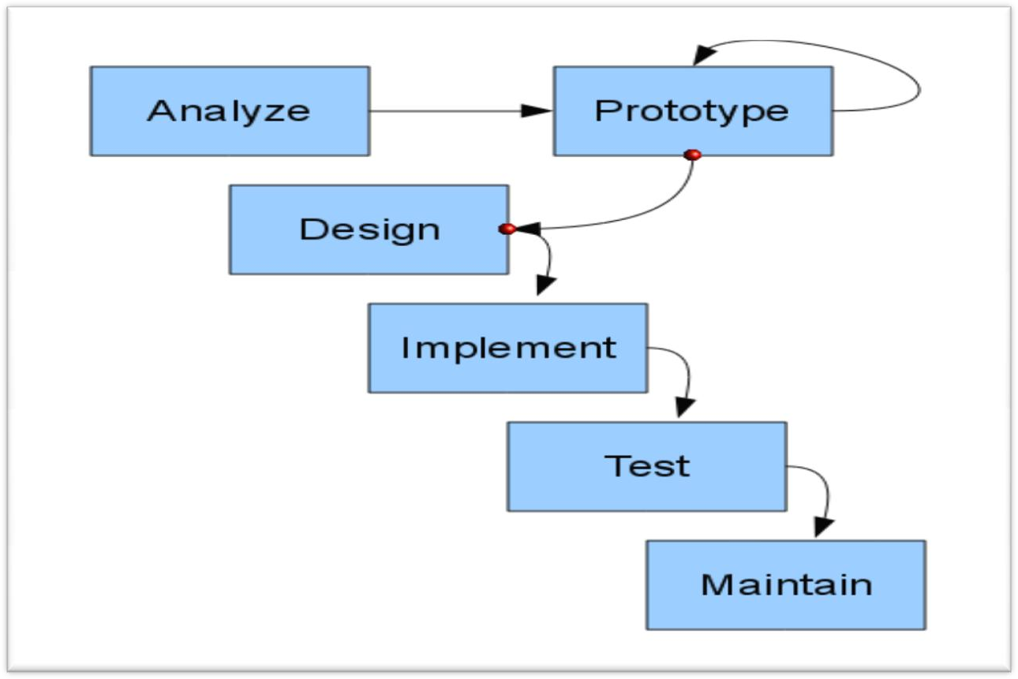

**Figure 3.1**: Prototype Model Process

**3.5.1 Prototype Model**

**Advantages of Prototyping**

• Shortens the time it takes to build a product.

• Lowers the cost of development.

• It necessitates user participation.

• Users provide measurable input to developers.

• Users will have a better understanding of what to anticipate from the

system, which will make it easier to implement.

• This leads to a greater level of user satisfaction.

• Informs developers about prospective system enhancements in the

future.

**Prototype Model Phases**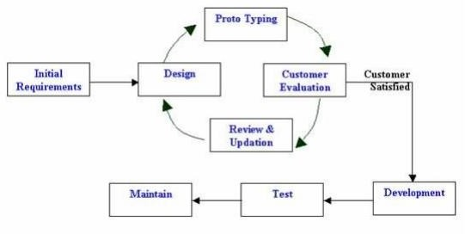

**Figure 3.2:** Prototype Model Phases.

**3.5.2 DFD in our System**

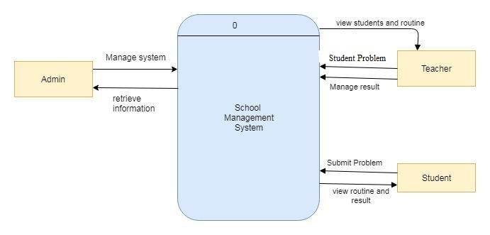

View students and courses

University Student performance prediction and Guiding System

Course Reg.

View prediction and guideline

**Figure 3.3**: Context Level Diagram for student performance and guiding system.

**3.6 Design, Implementation and Simulation**

The overall workflow of the proposed architecture is illustrated in Figure 3.1, 3.2 and 3.3. All the mentioned steps of the prototype are implemented using PHP, MySql, Html, Css, bootstrap, js. For additional calculation, implementation, and support, filtered method is used. The data used to test the architecture is directly inserted by admin, teacher and student, and no variations or selections were made while testing the architecture.

**3.7 Summary**

This chapter explains detailed works of the proposed system process using various modules. The overall architecture uses the Data analysis of the features as well.

# Chapter 4 IMPLEMENTATION, TESTING AND RESULT ANALYSIS

**4.1 Introduction**

In this chapter, the proposed architecture is tested and analyzed the data and overall process. This section contains the system setup that was carried out.

**4.2 Database Schema**

Database schema is the skeleton structure that represents the logical view of the entire database. It defines how the data is organized and how the relations among them are associated. It formulates all the constraints that are to be applied on the data. Our system has five database tables as shown in Figure 5.2. Each table contains an ID and several different attributes related to different functions in the system.

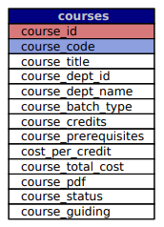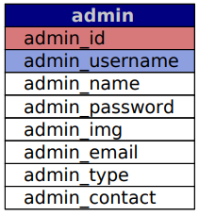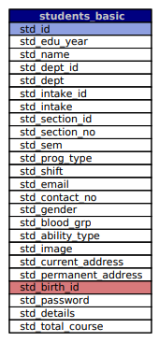 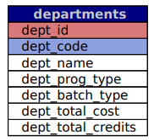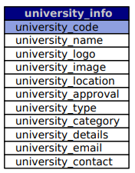

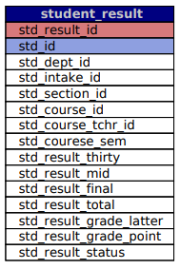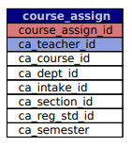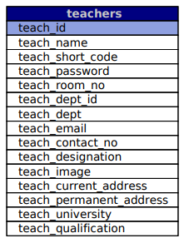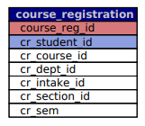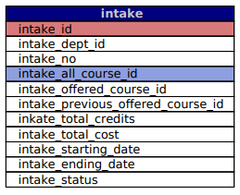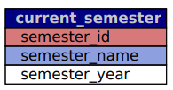

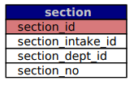

**Fig 4.1:** Database Schema

**4.3 Implementation Phase**

The implementation phase begins once the system's databases have been developed, and during this phase, many actions and techniques were utilized to create the website, as illustrated in below. The website's development begins with the creation of the website's structure in HTML5. The website's look was subsequently created using CSS3.The panorama was finally included into the webpage.

**4.3.1 Admin Module Functionalities**

**Step 1: Admin Login**

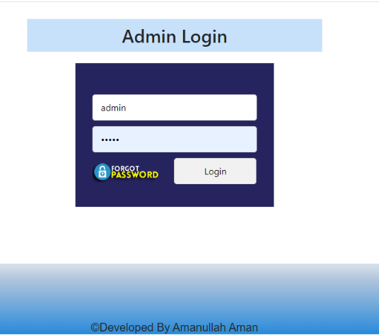

**Fig 4.2**: Admin Login

**Step 2: Admin Dashboard**

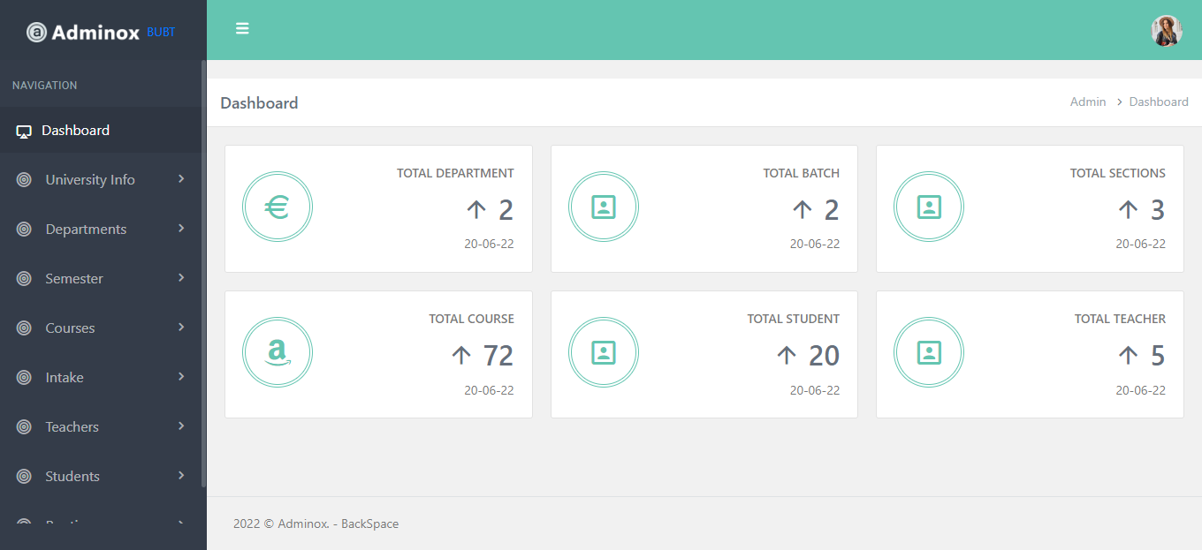

**Fig 4.3**: Admin Dashboard

**Step 3: Add University basic information**

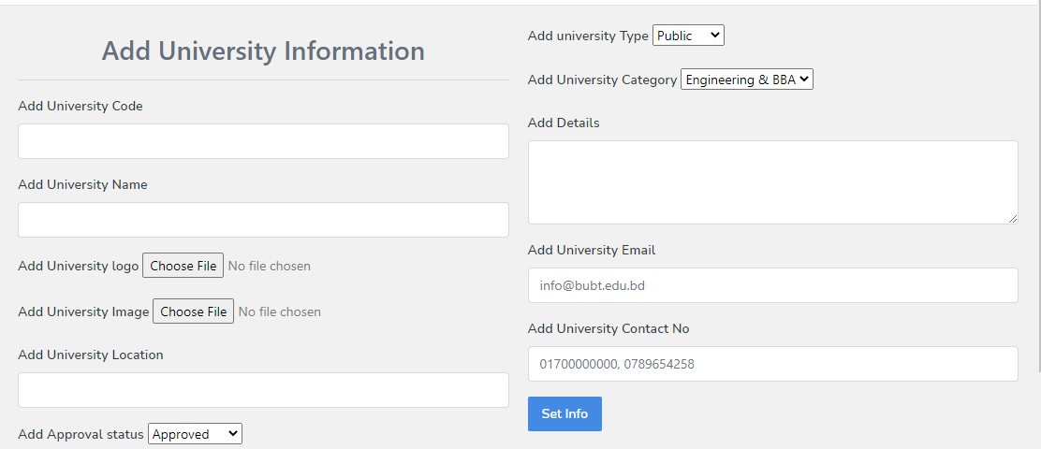

**Fig 4.4**: Add University basic info

**Step 4: Add Department**

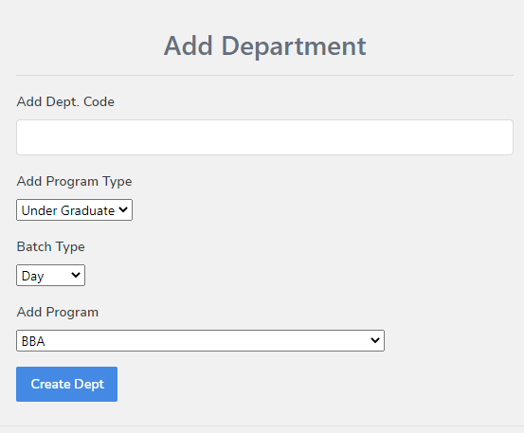

**Fig 4.5**: Add Department

**Step 5: Add Course Details**

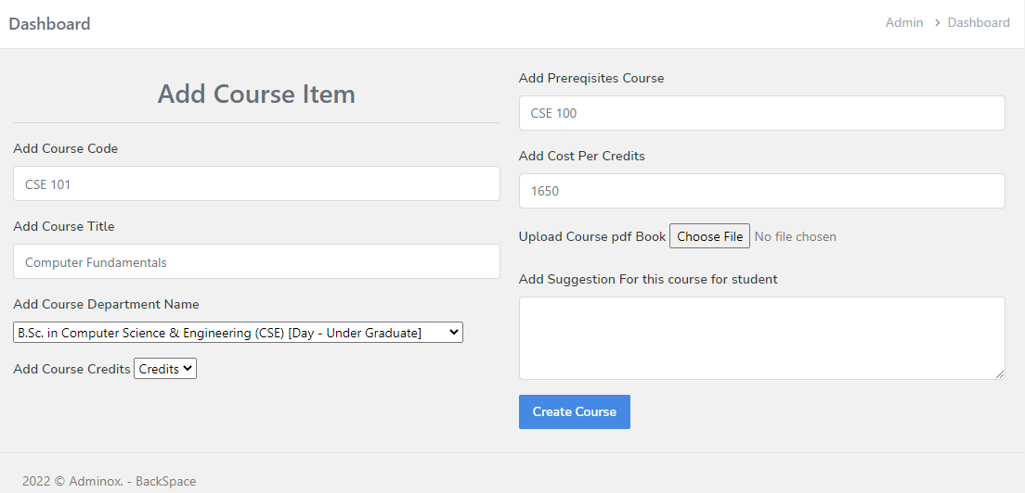

**Fig 4.6**: Add Course Details.

**Step 6: Add Current Semester**

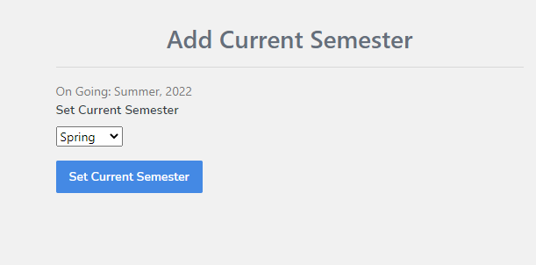

**Fig 4.7**: Add Current Semester.

**Step 7: Add New Intake**

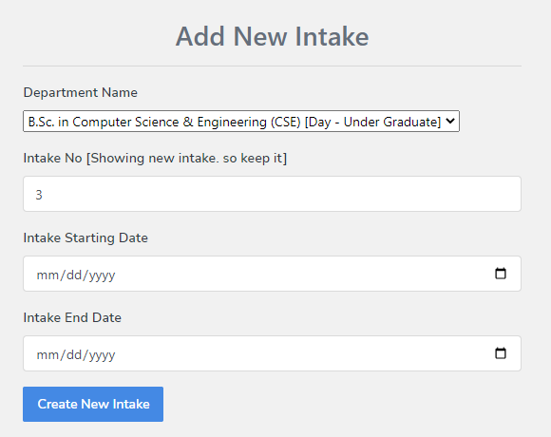

**Fig 4.8**: Add Intake.

**Step 8: Add New Section**

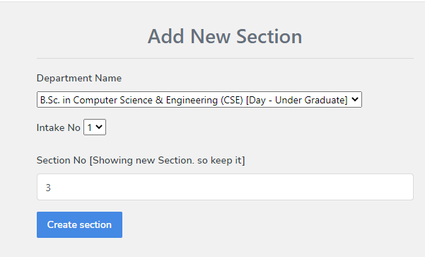

**Fig 4.9**: Add Section.

**Step 9: Student Admission**

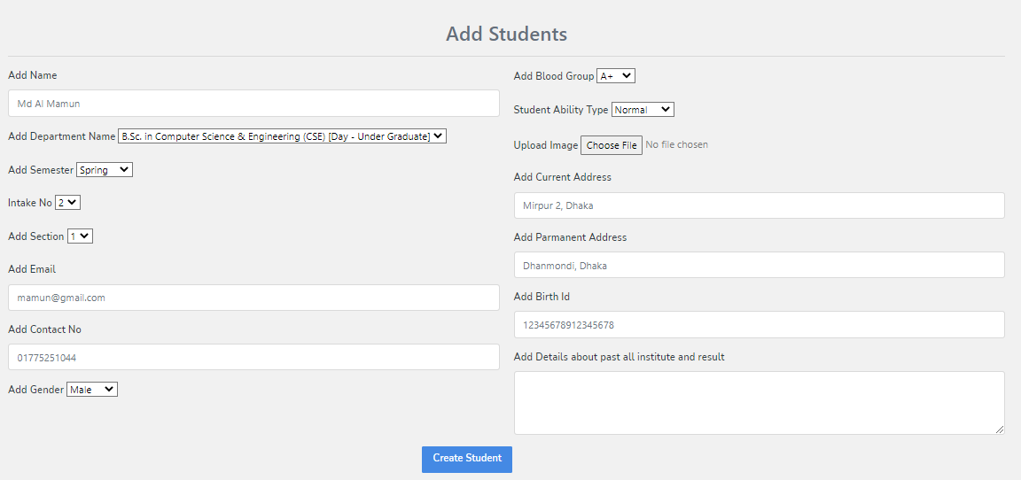

**Fig 4.10**: Add New Student.

**Step 10: Add New Teacher**

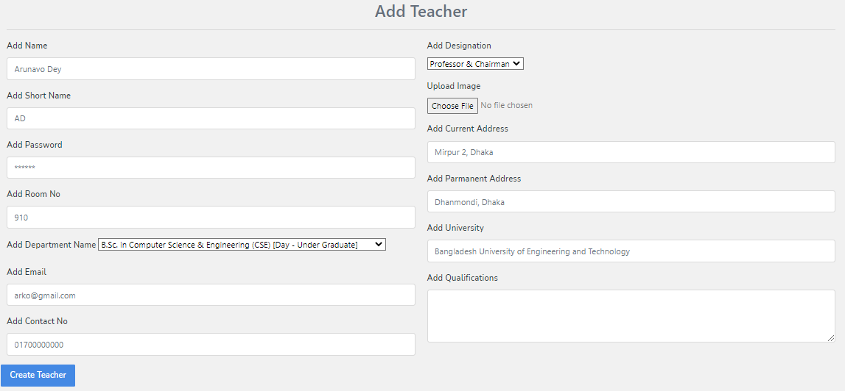

**Fig 4.11**: Add New Teacher.

**Step 11: Offer Courses to the Student for Registration**



**Fig 4.12**: Offer Courses.

**Step 12: Assign Courses to the Teacher**

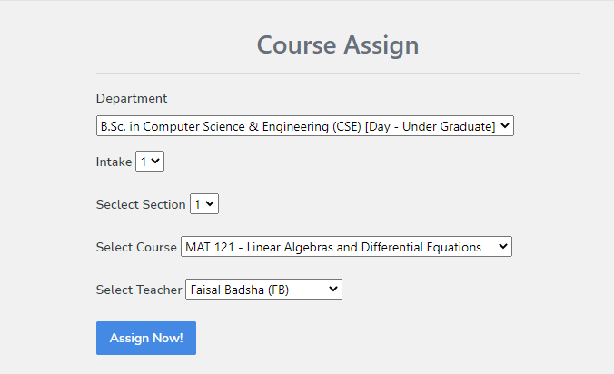

**Fig 4.13**: Assign Courses

**4.3.2 Student Module Functionalities**

**Step 1: Student Login**

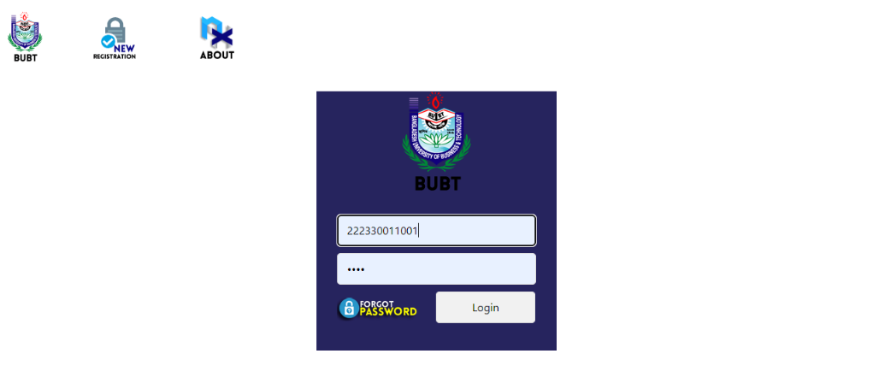

**Fig 4.14**: Student Login

**Step 2: Student Dashboard**

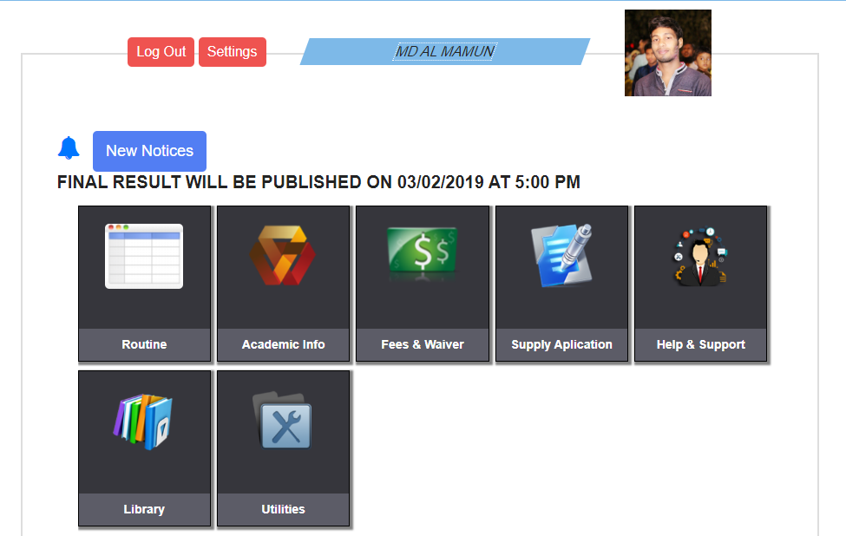

**Fig 4.15**: Student Dashboard

**Step 3: Academic Information**

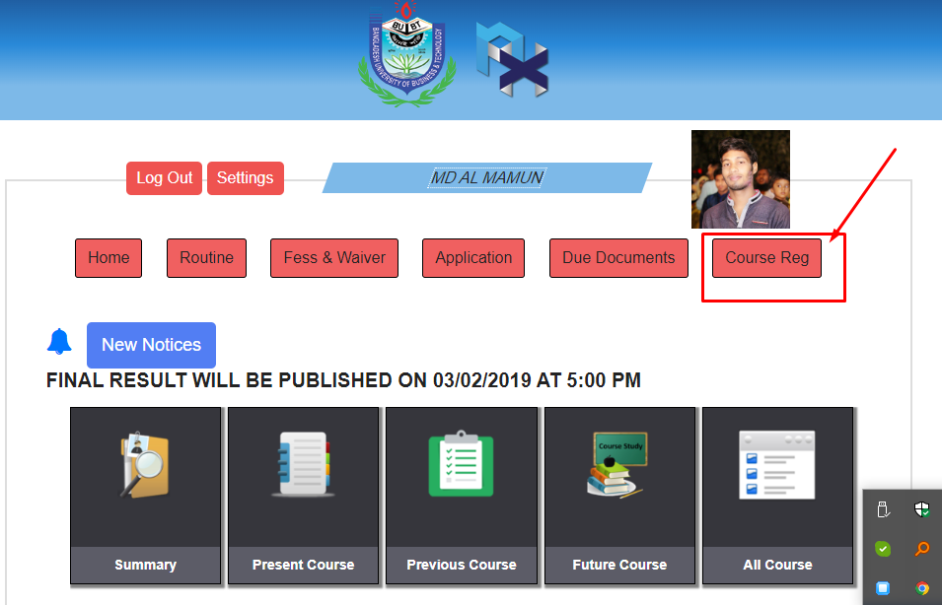

**Fig 4.16**: Academic Information

**Step 4: Course Registration**

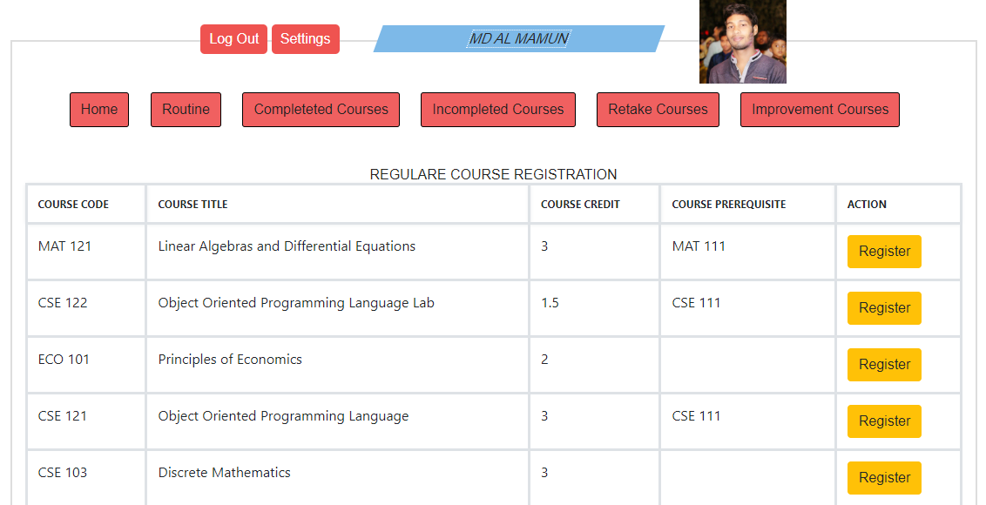

**Fig 4.17**: Course Registration

**4.3.3 Teacher Module Functionalities**

**Step 1: Teacher Login**

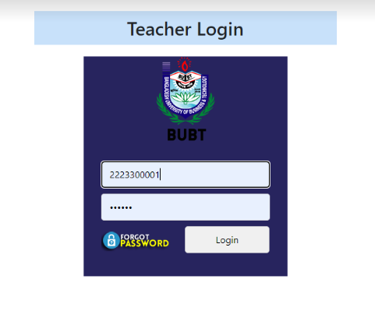

**Fig 4.18**: Teacher Login

**Step 2: Teacher Dashboard**

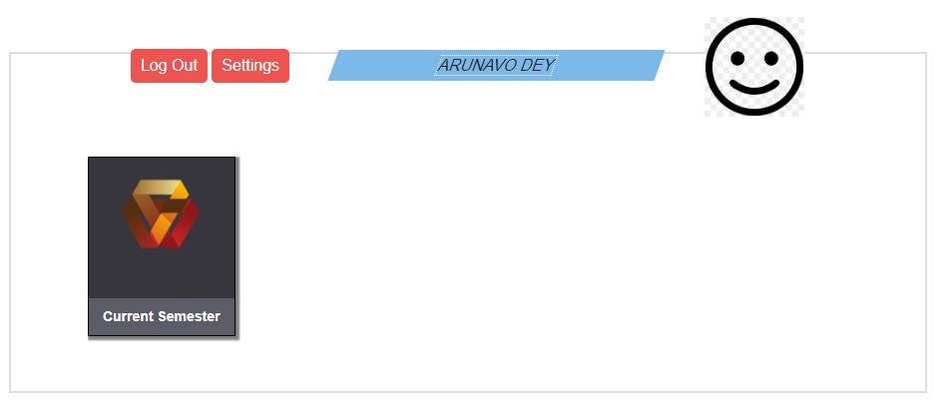

**Fig 4.19**: Teacher Dashboard

**Step 3: Assigned courses for teaching and evaluation**

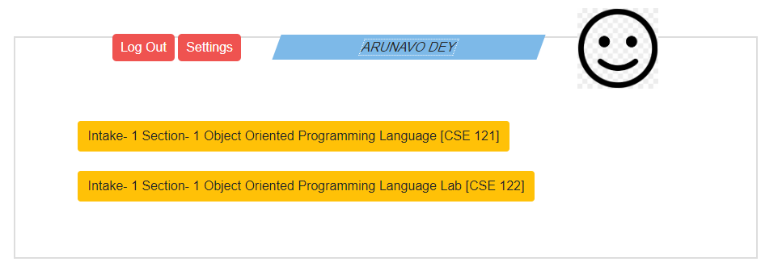

**Fig 4.20**: Assigned courses

**Step 3: Input Marks to the student for the course**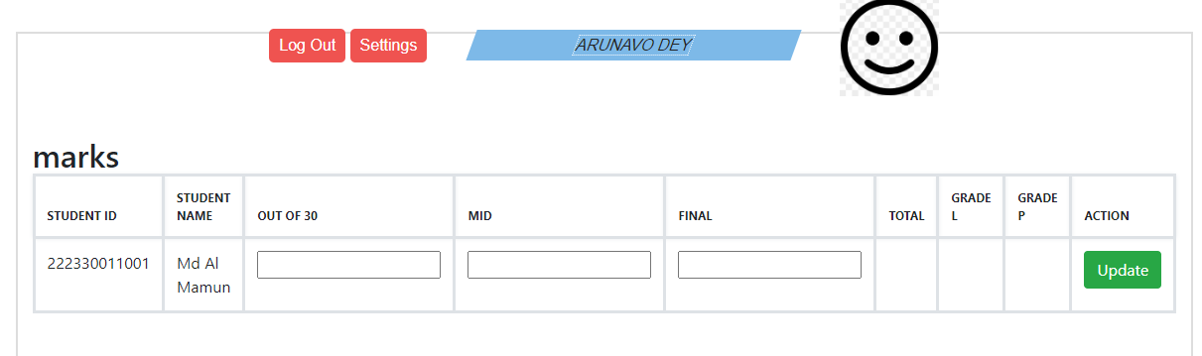

**Fig 4.21**: Input Marks

**4.4 Data Filtering Technique**

There are two level filtering in this system we have used. Firstly, when students will register course for current semester then for these courses previous student data of these courses will be filtered. The common grade of maximum student performances will be selected from 1000 student data then it will be shown for every registered courses. This prediction for each courses will be same for each student. This is the course average performance of previous maximum 1000 students. This filtering method will be applied for separately out of thirty marks, mid-term examination marks and final examination marks.

Another level of filtering technique is used to predict current semester performances based on previous semester student performances. Here previous semester student course grade will be selected and find the student of same grade of these courses. Then it will select the current semester courses and find the grade of these courses. After that select the maximum common grade for each out of thirty marks, mid-term marks, final examination marks. Finally, it will prediction for current semester courses for out of thirty marks, mid-term marks, final examination marks. And from this evaluation it will calculate the possible sgpa for current semester courses. Based on total marks, it will be shown guide line also.

**4.5 Testing and Result Analysis**

**Step 1: Student Academic information**

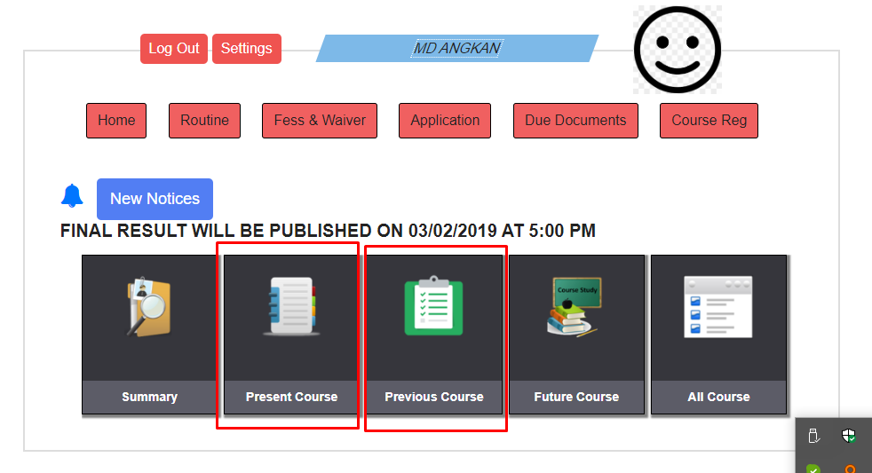

**Fig 4.22**: Academic Information

**Step 2: Student Previous Semester Courses**

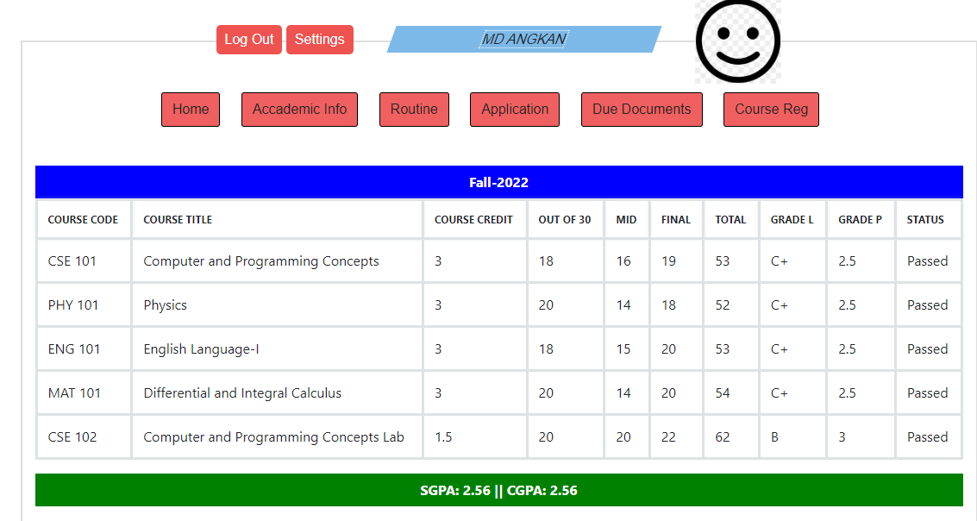

**Fig 4.23**: Previous Semester Courses performances

**Step 3: Student Present Semester Courses**



**Fig 4.24**: Present Semester Courses

**Step 4: Student Present Semester Courses Performances based on previous courses**

**data of maximum 100 students**

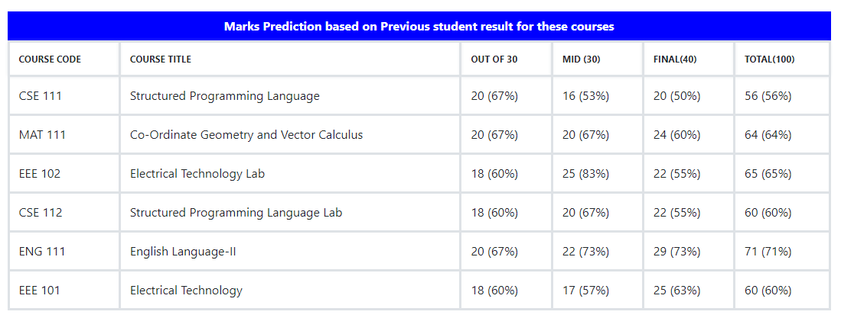

**Fig 4.25**: Performances Prediction based on previous course data

**Step 4: Student Present Semester Courses Performances based on previous semester**

**courses of specific student data of maximum 100 students**

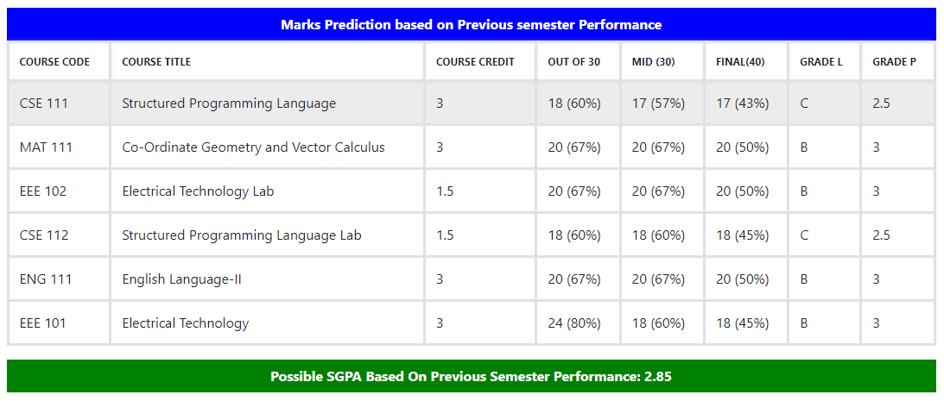

**Fig 4.26**: Performances Prediction based on previous semester course performances of specific student

**Step 4: Performances Progress and Guideline**

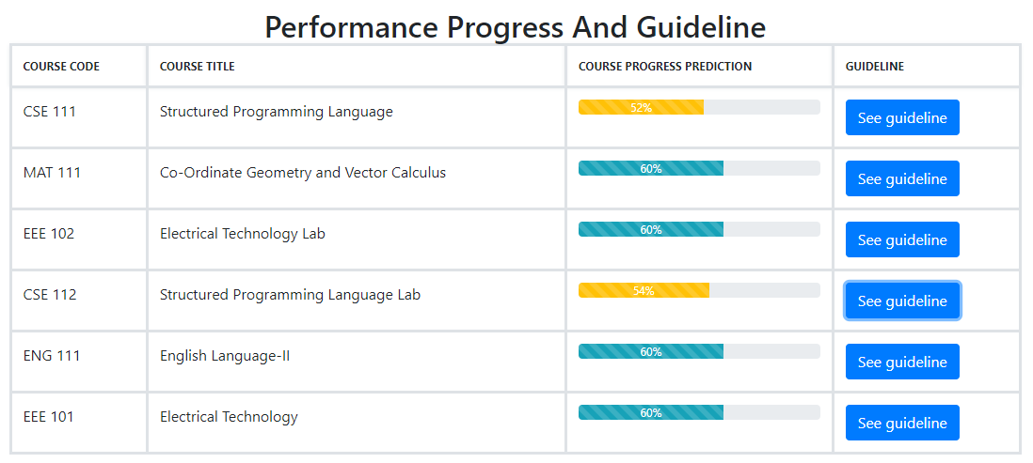

**Fig 4.27**: Performances Progress

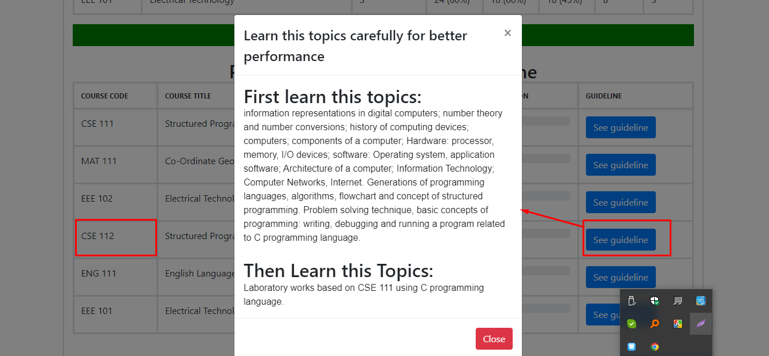

**Fig 4.28**: Guideline for Better Performances

**Step 4: Progress Bar Description**

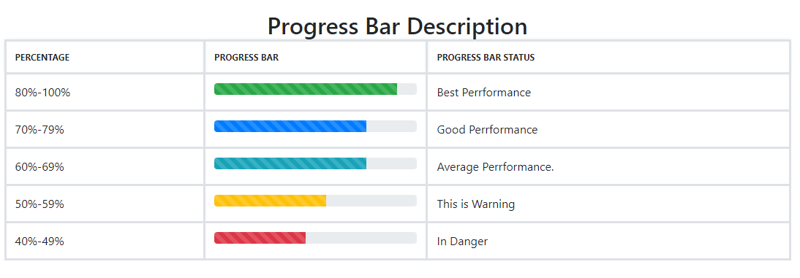

**Fig 4.29**: Progress Bar Description

**4.6 Summary**

In this evaluation report, we show that Data analysis performs the best accuracy filtering technique.

# Chapter 5 STANDARDS, IMPACTS AND CHALLENGES

**5.1 Impacts on Society**

This system is related to universities student. So we can say that this system has not impact directly to the society. But in addition this system can reduce student failing rate. So Student will be successful using this system. And that’s why unemployment rate will be reduced and they can be involved in social development.

**5.2 Challenges**

These days Data analysis and information disclosure are developing a critical innovation for researchers and businesses in numerous spaces. Data analysis was forming into a setup and confided in control, as yet forthcoming data analysis challenges must be tackled. Some of the Data analysis challenges are **Security and Social Challenges, Incomplete Data, Distributed Data, Complex Data, Performance, Incorporation of Background Knowledge, Data Visualization, Data Privacy and Security, Methodology Challenges.**

**5.3 Summary**

The message of this chapter is mainly about the effectiveness, didactics and adversity of the system. In short, we can say that to improve performances of students this system may quite fruitful. This chapter discusses also about the effects off this system based on filtering of student data. The system will create a positive vibe undoubtedly in the society.

# Chapter 6

# CONSTRAINTS AND ALTERNATIVES

**6.1 Project Constraints**

A constraint is something that limits or controls what you can do. Due to Data complexity we could not able to implement Machine Learning.

**6.2 Design Constraints**

Design constraints are those inflicted on the design solution and it is the limitations on a design. When we got the opportunity to work on it, it was very difficult to understand the terminologies, equally mundane to remember method names and very tough to design a solution using filtering. It needed significant amount of time to spend at search engines, still it did not match with the understanding acquired by resolving production issues, understanding existing designs and making others understand how does it ensure security.

**6.3 Component Constraints**

The component requirements of the proposed architecture include,

* Minimum Processor Requirement: Intel i3 (3rd Gen, 2.4GHz)
* Minimum Memory Requirement: 4GB (DDR3, 1600 bus)
* Minimum Platform Requirement: Web Server

**6.4 Budget Constraints**

The estimated budget is to be calculated by the current market price of the component

requirements.

**6.5 Summary**

The message of this chapter is mainly about the effectiveness, didactics and adversity of the system. Here in this chapter, we tried to highlight some facts that cannot be ignored in the whole procedure.

# Chapter 7 SCHEDULES, TASKS AND MILESTONES

**7.1 Timeline**

Our project work is separated into three sections due to the fact that we have three semesters to complete it. Our work was completed according to our supervisor's instructions. We submitted a proposal and examined associated work during the first semester. In addition, we created a prototype for the planned systems by analyzing and planning with existing systems. In the second section, we partially implemented it in the second semester. Finally, we developed the overall design and reported the overall workflow in the third semester.

**7.2 Gantt Chart**

The following Gantt chart (Figure 7.1) represents the work execution process to complete this project work. The project work is completed within three semesters, where per semester is four-month which means 12 months in total.

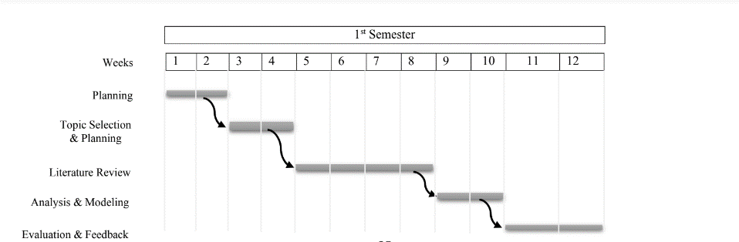

**Analysis & Filtering**

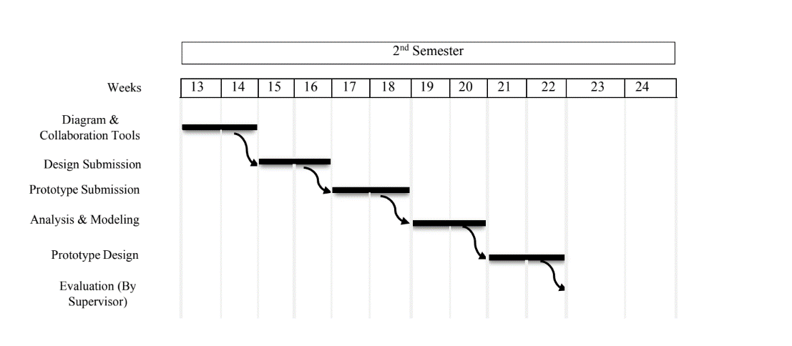

**Analysis & Filtering**

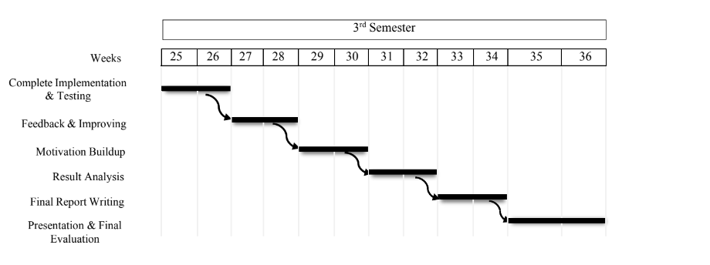

Figure 7.1: Gantt chart of the work execution process.

# Chapter 8 CONCLUSION AND FUTURE WORK

**8.1 Conclusion**

Classification is the major data analysis technique which is primarily used in health-care sectors for medical diagnosis and predicting diseases. This research work used classification algorithms namely Support Vector Machine (SVM), Logistic Regression, Random Forest, Decision Tree, and K Nearest Neighbors classifier for liver disease prediction. Comparisons of these analysis are done and it is based on the performance factors classification accuracy and execution time. From the experimental results, this work concludes, the Random Forest classifier is considered as a best algorithm because of its highest classification accuracy. On the other hand, while comparing the execution time, the Logistic Regression classifier needs minimum execution time.

**8.2 Future work**

Nothing is 100% correct in this world. So, our work is not done yet. We need to improve our model using various technique. Some of them is given bellow,

* Adding Machine Learning Algorithm to increase accuracy of our system.
* Applying data synthesis method to increase dataset.
* Developing an application for android devices that works on the same database.
* Putting this system on live server and updating it through internet.

REFERENCES

[1] M. F. Sikder, M. J. Uddin, S. Halder, “Predicting Students Yearly Performance using Neural Network: A Case Study of BSMRSTU” 5th International Conference on Informatics, Electronics and Vision (ICIEV), 524-529, 2016. https:// doi: 10.1109/iciev.2016.7760058.

[2] Shubhangi Shankar Shinde1, Dr. Bhatambrekar S.S.2 Dipali Meher “Result Analysis of Choice Base Credit System” 2016.

[3] Kamaljit Kaur* and KuljitKaur,"Analyzing the Effect of Difficulty Level of a Course on Students Performance Prediction using Data Mining." 2015.

[4] ZhiwuLiu,Xiuzhi Zhang,"Prediction and Analysis for Students Marks Based on Decision Tree Algorithm." 2010.

[5] S.Taruna, Mrinal Pandey,"An Empirical Analysis of Classification Techniques for Predicting Academic Performance."2014.

[6] Havan Agrawal, HarshilMavani,"Student Performance Prediction using Machine Learning."2015.

[7] SnehalKekane, DipikaKhairnar, Rohini Patil, Prof. S.R.Vispute,Prof. N. Gawande " Automatic Student Performance Analysis and Monitoring." 2016.

[8] R. R.Kabra,R. S. Bichkar, "Performance Prediction of Engineering Students using Decision Trees." 2011.

[9] B. K. Baradwaj, S. Pal, "Mining Educational Data to Analyze Students Performance" International Journal of Advanced Computer Science and Applications,2(6),2011. https://doi.org/doi:10.14569/IJACSA.2011.020609.

[10] S. K. Yadav, S. Pal, “Data Mining Application in Enrolment Management: A Case Study” International Journal of Computer Application (IJCA), 41(5), 1- 6, 2012. https:// doi: 10.5120/5534-7581.

[11] C. Romero, S. Ventura, P. G. Espejo, C. Hervás, “Data Mining Algorithms to

Classify Students” In EDM, 8-17, 2008.

[12] L. A. Whitley, "Educational data mining and its uses to predict the most prosperous

learning environment" M.Sc. Thesis, East Carolina University in USA, 2018.

[13] A. O. Ogunde, D. A. Ajibade, "A Data Mining System for Predicting University Students’ Graduation Grades Using ID3 Decision Tree Algorithm" Journal of Computer Science and Information Technology, 2(1), 21-46, 2014.

[14] N. A. Gorikhan, “A study on Implementation of classification techniques to predict students’ results for Institutional Analysis” MSc Thesis, Faculty of Engineering & IT, The British University in Dubai, 2016.

[15] B. K. Bhardwaj, S. Pal, "Data Mining: A prediction for performance improvement using classification" International Journal of Computer Science and Information Security (IJCSIS), 9(4), 136-140, 2011.

[16] Farhana Sarker, Thanassis Tiropanis and Hugh C Davis, Students’ Performance Prediction by Using Institutional Internal and External Open Data Sources, http://eprints.soton.ac.uk/353532/1/Students' mark prediction model.pdf, 2013.

[17] D. M. D. Angeline, Association rule generation for student performance analysis using an apriori algorithm, The SIJ Transactions on Computer Science Engineering & its Applications (CSEA) 1 (1) (2013) p12–16.

[18] Abeer Badr El Din Ahmed and Ibrahim Sayed Elaraby, Data Mining: A prediction for Student's Performance Using Classification Method, World Journal of Computer Application and Technology 2(2): 43-47, 2014.